Name: ____________________

Gummi Bear Football

- Measure your Gummi Bear in inches.

- Convert the height of the average football player into inches. The average football player on a team is 6’2” tall.

- How many times taller is the average NFL player than the Gummi Bear?

- Using the dimensions on the football field, find the new dimensions for the Gummi Bear Field. Pleas fill out the table below. You may use calculators.
Dimensions | Original Football  Field | Proportion | Gummi Bear Field
Length of Football Field
Width of Field
Length of End Zone
Distance to the Goal Post
Width of Goal Post
Distance between Each 10 Yards
Distance from edge of field to hash marks

- Using a ruler and the correct dimensions, create a football field for the Gummi Bears. Please color and label it. Also, create a team logo and decorate the field as if you would see it on tv.

- The goal post on a football field is a length of 23’4” and a height of 25”. Find the dimensions for the goal post on the Gummi Bear Field.

- A footballs has a length of 11 inches and a circumference of 22 inches. What are the dimensions of a Gummi Bear football?

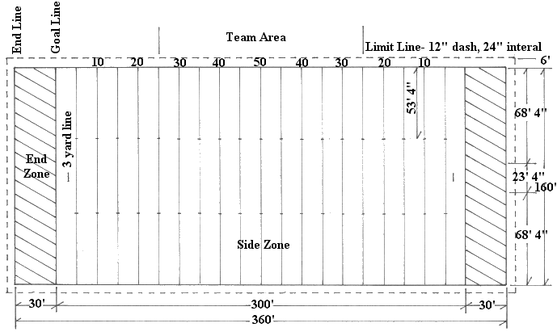
Name: ____________________

Gummi Bear Soccer Field

- Measure your Gummi Bear in inches.

- Convert the height of the average soccer player into inches. The average soccer player is 5’ 10”.

- How many times taller is the average soccer player than the Gummi Bear?

- Using the dimensions on the soccer field, find the new dimensions for the Gummi Bear field. Please fill in the table below. You may use calculators.

Dimensions | Original Soccer Field | Proportion | Gummi Bear Field
Length of Field
Width of Field
Length and Width of Goal Box
Length and Width of Penalty Box
Diameter of Center Circle
Distance from end of field to halfway line
Length and width of goal
Distance from corner of field to edge of arc

- Using a ruler and the correct dimensions, create a soccer field for the gummi bears. Please color and label it. Also, create a team logo and decorate the court as if you would see it on tv.

- The goal net is 8 feet tall and 24 feet long. What would be the measurements for the Gummi Bear goal?

- A soccer ball has a diameter of 22 cm. What is the diameter of the soccer ball used in the Gummi Bear court?

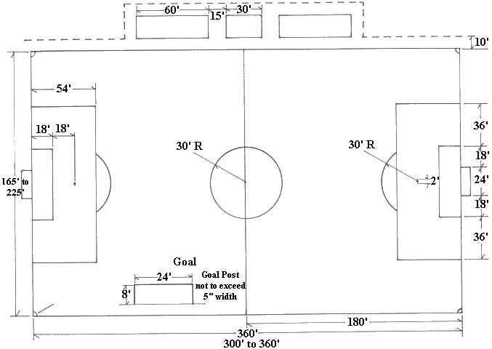

Name: _____________________
Gummi Bear Volleyball Court

- Measure your Gummi Bear in inches.

- Convert the height of the average volleyball player into inches. The average height of a volleyball player is 5’10”.

- How many times taller is the average volleyball player than the Gummi Bear?

- Using the dimension on the volleyball court, find the new dimensions for the Gummi Bear Court. Please fill out the table below. You may use calculators.
Dimensions | Original Volleyball Court | Proportion | Gummi Bear Court
Length of court
Width of court
Length to net
Length to attack line
Length of serving area
Width of serving area

- Using a ruler and the correct dimensions, create a volleyball court for the Gummi Bears. Please color and label it. Also, create a team logo and decorate the court as if you would see it on tv.

- The volleyball net measures 32 feet long and 3 feet high. What would these measurements be for the Gummi Bear Court?

- A standard volleyball has a diameter of 21.5 cm. What would a Gummi Bear volleyball’s diameter be?

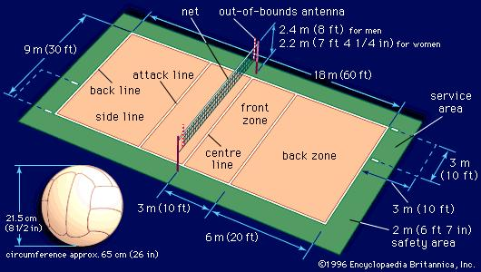

Name: ___________________
Gummi Bear Basketball

- Measure your Gummi Bear in inches.

- Convert the height of the average basketball player into inches. The average basketball player is 6’6” tall.

- How many times taller is the average NBA player than the Gummi Bear?

- Using the dimensions on the basketball court, find the new dimensions for the Gummi Bear court. Please fill out the table below. You may use calculators.
Dimensions | Original Basketball Court | Proportion | Gummi Bear Court
Length of the court
Width of the Court
Distance from the edge of court to free throw line
Width of free throw line
The distance from the center of the basket to the three point line
Distance from the edge of court to the side of the free throw line
The diameter of the circle in the middle of the court
The distance between the marks alongside the key

- Using a ruler and the correct dimensions, create a basketball court for the Gummi Bears. Please color and label it. Also, create a team logo and decorate the court as if you would see it on tv.

- The NBA backboard is 72 inches long and 42 inches high. The diameter of the rim is 18 inches. What would the measurements be for the Gummi Bears?

- The circumference of a basketball is 29.5 inches and the diameter is 9.4 inches. What are the dimensions of the Gummi Bear Basketball?

